Covid FAQ’s at 3 March 2022

What safety measures are in place on campus?
We are continuing with the following safety measures on our campuses:
• Hand sanitising stations – hand sanitiser is available to all our students and staff, and should be used regularly while on site. This is in addition to the fact you should regularly wash your hands for at least 20 seconds throughout the day.
• Maintain cleaning, including frequently touched surfaces – disinfectant wipes are available in all classrooms. Students and staff should use the wipes available to clean down their desk before and after lessons or as required
• Keep occupied spaces well ventilated – windows should remain open to allow for fresh air to circulate throughout the day and therefore students and staff may wish to wear more clothing layers
• Follow Public Health advice- this includes guidance on testing and providing information to students and staff who are symptomatic or test positive
https://www.gov.uk/government/publications/covid-19-people-with-covid-19-and-their-contacts/covid-19-people-with-covid-19-and-their-contacts

What is expected of me as a member of staff/student on site?
You should follow all the safety measures listed above.
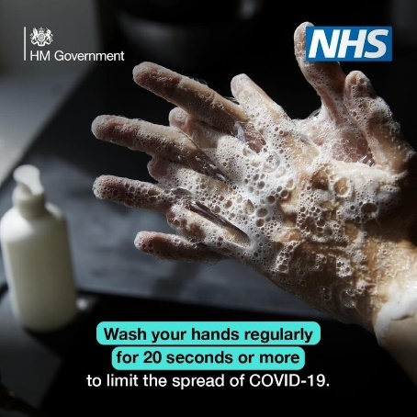
There are things you can do to help reduce the risk of you and anyone around you getting ill with COVID-19:
• Wash your hands with soap and water often – do this for at least 20 seconds
• Use hand sanitiser gel if soap and water are not available
• Wash your hands as soon as you get to College and when you return home
• Cover your mouth and nose with a tissue or your sleeve (not your hands) when you cough or sneeze
• Put used tissues in the bin immediately and wash your hands afterwards – catch it, bin it, kill it!

Additionally, take up the offer of both doses of the vaccine as soon as you become eligible.
More information on how to get the vaccine please visit:
https://www.nhs.uk/conditions/coronavirus-covid-19/coronavirus-vaccination/book-coronavirus-vaccination/

If you develop symptoms of Covid-19, do not come into college. Follow advice given in the Frequently Asked Questions below.

What are the symptoms of coronavirus?
You should look for any of the following symptoms:
• New continuous cough
• Fever or high temperature
• Loss of, or change in, normal sense of taste or smell (anosmia)
If you develop these symptoms, however mild, at any point, you must stay at home and avoid contact with other people. You should order a PCR test and inform College and follow the government guidance
https://www.gov.uk/government/publications/covid-19-people-with-covid-19-and-their-contacts/covid-19-people-with-covid-19-and-their-contacts
Please follow the normal College absence procedures by calling the student absence line on 01282 440293 or email absence@nelsongroup.ac.uk.

What do I do if I get a positive test result?
If you test positive for covid stay at home and please inform College immediately by emailing health@nelsongroup.ac.uk and follow the the government guidance.

https://www.gov.uk/government/publications/covid-19-people-with-covid-19-and-their-contacts/covid-19-people-with-covid-19-and-their-contacts

What do I do if I’m a close contact of someone who tested positive for COVID-19?
If you have had close contact with a positive case, unless you have symptoms yourself, you should still come into college.

If you are unsure whether you should come into college or not, please get in touch with us and we can help to determine the next steps for you.
Call 01282 440226 or email health@nelsongroup.ac.uk.

Do I have to wear a face mask?

It is no longer a requirement to wear a face mask in college, however, students and staff are at liberty to wear face coverings where they feel more comfortable doing so.

Should I attend college if I have been advised to shield?
Clinically extremely vulnerable students should attend college unless they have been advised by their GP or Clinician not to attend.
If you have any college related questions about this matter please email nurse@nelsongroup.ac.uk

Why are the windows open in college when it is cold weather?
The government campaign demonstrates the importance of simple ventilation techniques to reduce the risks of catching COVID-19 .
Research shows that being in a room with fresh air can reduce the risk of infection from particles by over 70% *( ref Department of Health & Social Care)
Click here to watch the film that illustrates how coronavirus lingers in the air in spaces with no fresh air, increasing the risk of people breathing in infected particles, and how the risk can be reduced significantly by regularly ventilating enclosed areas.
Windows should be opened for 10 minutes every hour to reduce the risk of catching Covid 19

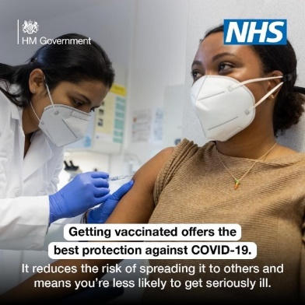

Where can I get more information about the COVID-19 vaccine?

Click here for more information on the Covid-19 Vaccine

https://www.nhs.uk/conditions/coronavirus-covid-19/coronavirus-vaccination/

Will I miss any college work if I have to stay at home due to covid?
Should you need to stay at home because you have:
• Tested positive
• Symptoms of covid
Your tutors will support you to ensure you can catch up with work, or if you feel well enough, make arrangements for you attend remote sessions where this is an option.

